Ray in Solid Geometry

Definition
# Source: AI Source: Provided by: [Data Path: Persons Table -> ID Column: 1, Name_En Column: Motasem Essam] -> From: [ChatGPT] on [7/25/2026]
A Ray in Solid Geometry is a part of a straight line that begins at one endpoint and extends infinitely in one direction through three-dimensional space. It has a starting point but no endpoint in its direction of extension.
A ray can lie within a plane, pass through a solid, or extend in any direction in three-dimensional space.

Simple Definition
# Source: AI Source: Provided by: [Data Path: Persons Table -> ID Column: 1, Name_En Column: Motasem Essam] -> From: [ChatGPT] on [7/25/2026]
A ray is a straight path that starts at one point and continues forever in one direction.
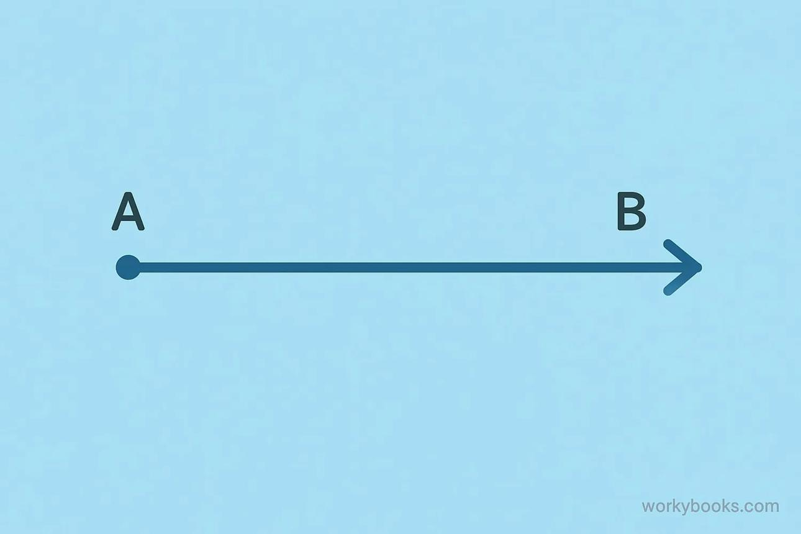
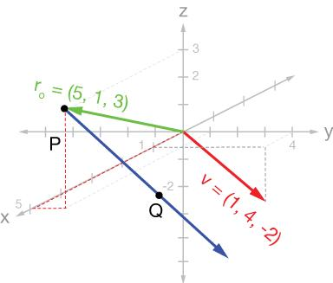
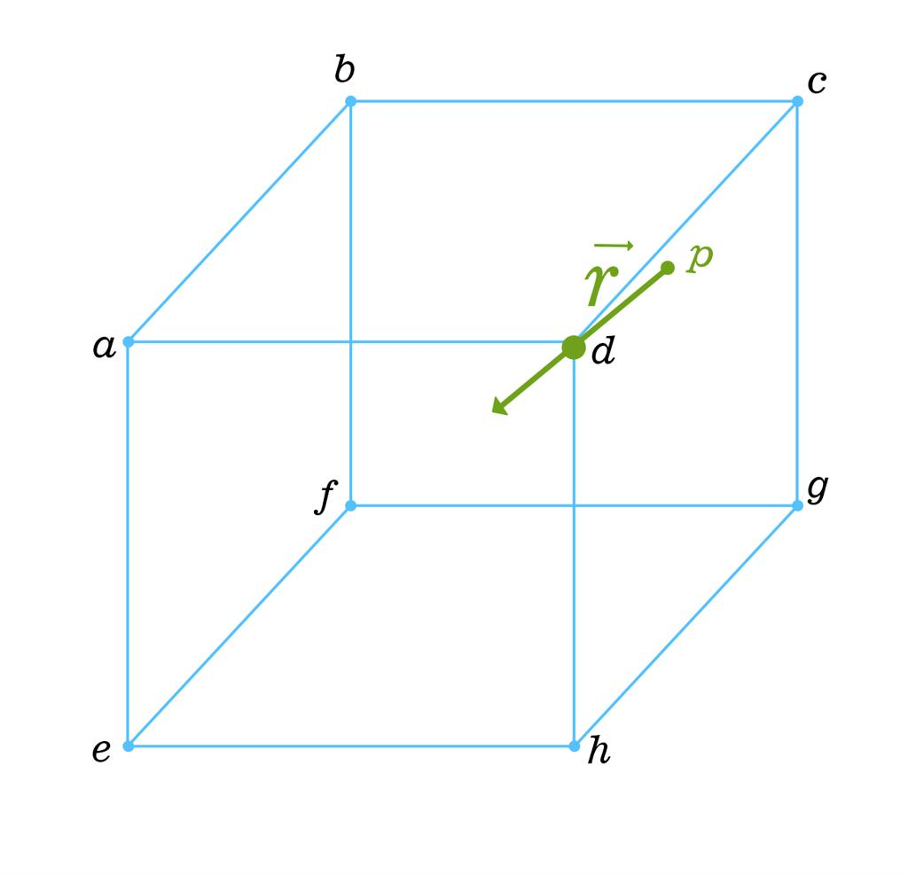

Fundamental Properties
# Source: AI Source: Provided by: [Data Path: Persons Table -> ID Column: 1, Name_En Column: Motasem Essam] -> From: [ChatGPT] on [7/25/2026]
- One Endpoint: A ray has exactly one starting point, called its origin.
- Infinite Extent: It extends infinitely in one direction.
- One-Dimensional: It has length but no width or thickness.
- Straightness: A ray follows a straight path without curvature.
- Direction: Its direction is determined by its origin and another point along the ray.
- Infinite Length: Because it extends indefinitely, a ray has no finite total length.

Main Types of Rays in Solid Geometry
# Source: AI Source: Provided by: [Data Path: Persons Table -> ID Column: 1, Name_En Column: Motasem Essam] -> From: [ChatGPT] on [7/25/2026]
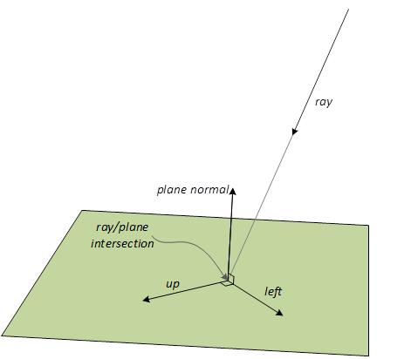

1. Ray in Space
# Source: AI Source: Provided by: [Data Path: Persons Table -> ID Column: 1, Name_En Column: Motasem Essam] -> From: [ChatGPT] on [7/25/2026]
A ray in space starts at one point and extends infinitely in a fixed direction through three-dimensional space.

2. Ray in a Plane
# Source: AI Source: Provided by: [Data Path: Persons Table -> ID Column: 1, Name_En Column: Motasem Essam] -> From: [ChatGPT] on [7/25/2026]
A ray in a plane lies entirely within a particular plane and extends infinitely in one direction from its origin.

3. Ray Originating at a Vertex
# Source: AI Source: Provided by: [Data Path: Persons Table -> ID Column: 1, Name_En Column: Motasem Essam] -> From: [ChatGPT] on [7/25/2026]
A ray may begin at a vertex of a solid and extend outward or pass through the solid. Its direction does not have to follow an edge.

4. Ray Intersecting a Plane
# Source: AI Source: Provided by: [Data Path: Persons Table -> ID Column: 1, Name_En Column: Motasem Essam] -> From: [ChatGPT] on [7/25/2026]
A ray may intersect a plane at a point. Depending on its position, it may begin on the plane, cross the plane, or lie entirely within the plane.

5. Ray Defined by a Point and Direction
# Source: AI Source: Provided by: [Data Path: Persons Table -> ID Column: 1, Name_En Column: Motasem Essam] -> From: [ChatGPT] on [7/25/2026]
A ray can be described mathematically using its starting point and a direction vector, which specifies the direction in which it extends.

Representation and Notation
# Source: AI Source: Provided by: [Data Path: Persons Table -> ID Column: 1, Name_En Column: Motasem Essam] -> From: [ChatGPT] on [7/25/2026]
A ray starting at $A$ and passing through $B$ is written as
$$\overset{→}{AB}$$
The first letter $A$ identifies the origin, and the second letter $B$ identifies the direction.
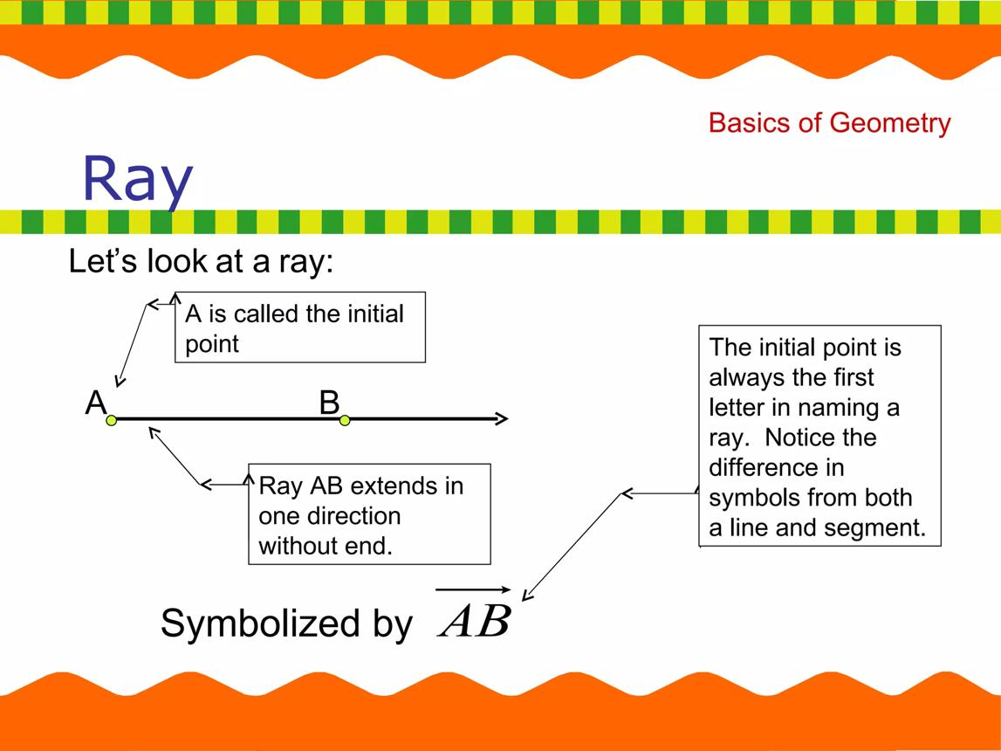
The ray contains its origin $A$ and all points continuing from $A$ through $B$ in the same direction.
Importantly, $\overset{→}{AB}$ and $\overset{→}{BA}$ generally represent different rays.

Representation in Three-Dimensional Coordinates
# Source: AI Source: Provided by: [Data Path: Persons Table -> ID Column: 1, Name_En Column: Motasem Essam] -> From: [ChatGPT] on [7/25/2026]
A ray in three-dimensional Cartesian space can be described by its origin and a direction vector.
Let the origin be
$$P_{0}=\left(x_{0},y_{0},z_{0}\right)$$
and let its direction vector be
$$v=\left(a,b,c\right)$$
The ray is represented parametrically by
$$\boxed{\begin{aligned}x&=x_{0}+at \\ y&=y_{0}+bt \\ z&=z_{0}+ct\end{aligned} t≥0}$$
Unlike the parameter for a complete line, which can take any real value, the ray's parameter satisfies $t\backslash geq0$. This ensures that it extends only forward from its origin.
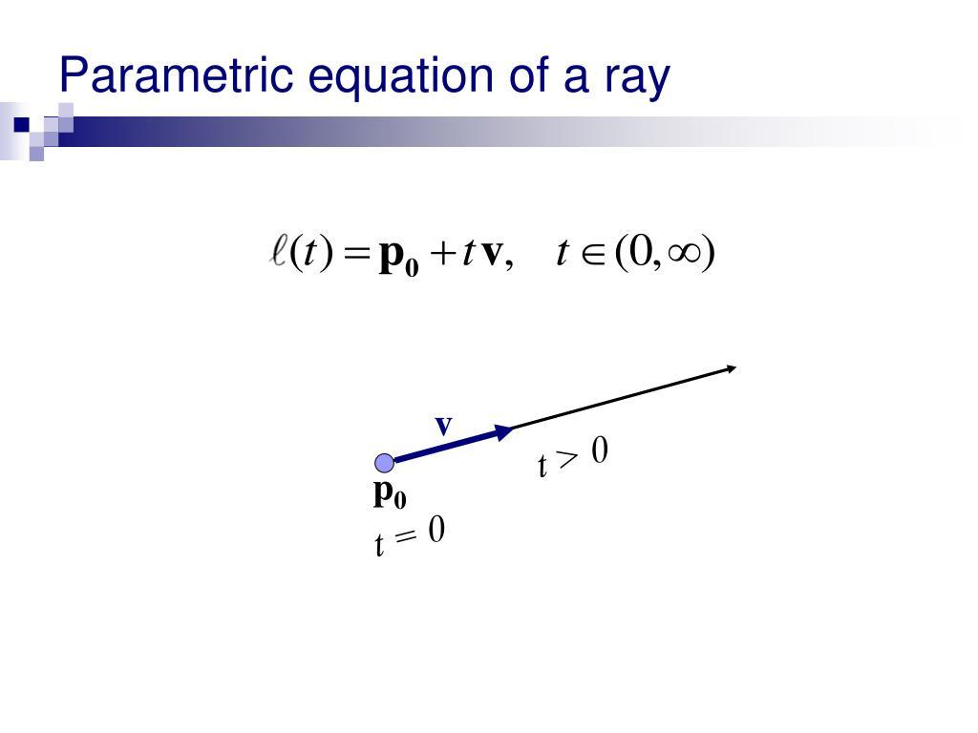
Example
Suppose a ray starts at $P_0=(1,2,3)$ with direction vector $v=\left(2,1,-1\right)$.
Its equations are
$$\begin{aligned}x&=1+2t \\ y&=2+t \\ z&=3-t, t≥0\end{aligned}$$
- When $t=0$, the ray begins at $\left(1,2,3\right)$.
- When $t=1$, it passes through $\left(3,3,2\right)$.
- When $t=2$, it passes through $\left(5,4,1\right)$.
The ray continues in the same direction for all $t≥0$.

Relationships Between Rays and Other Geometric Objects
# Source: AI Source: Provided by: [Data Path: Persons Table -> ID Column: 1, Name_En Column: Motasem Essam] -> From: [ChatGPT] on [7/25/2026]
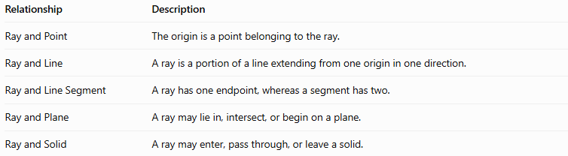
Relationship | Description
Ray and Point | The origin is a point belonging to the ray.
Ray and Line | A ray is a portion of a line extending from one origin in one direction.
Ray and Line Segment | A ray has one endpoint, whereas a segment has two.
Ray and Plane | A ray may lie in, intersect, or begin on a plane.
Ray and Solid | A ray may enter, pass through, or leave a solid.

Ray vs. Line vs. Line Segment
# Source: AI Source: Provided by: [Data Path: Persons Table -> ID Column: 1, Name_En Column: Motasem Essam] -> From: [ChatGPT] on [7/25/2026]
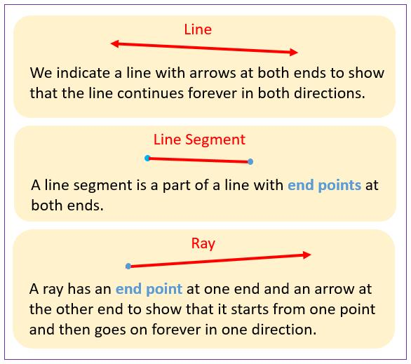
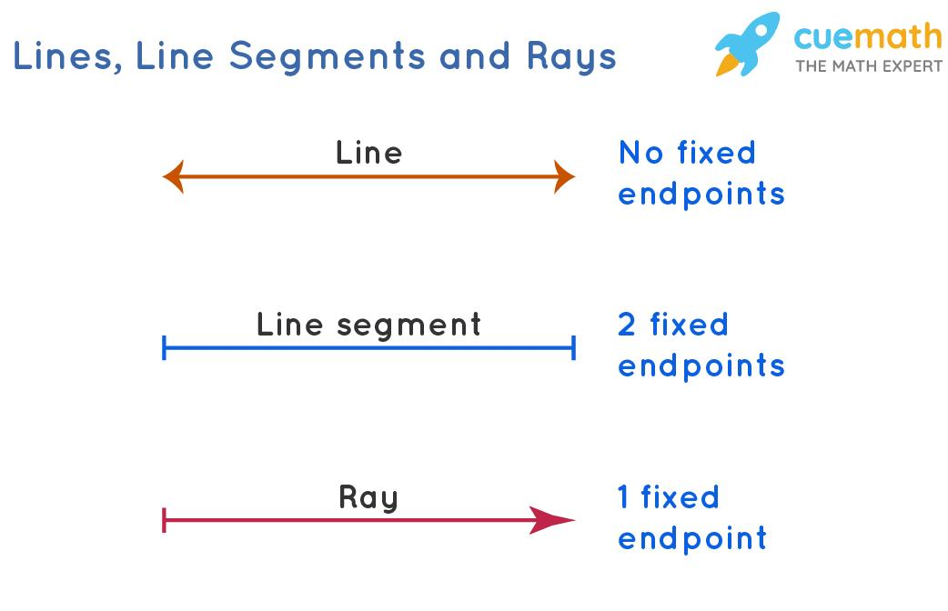
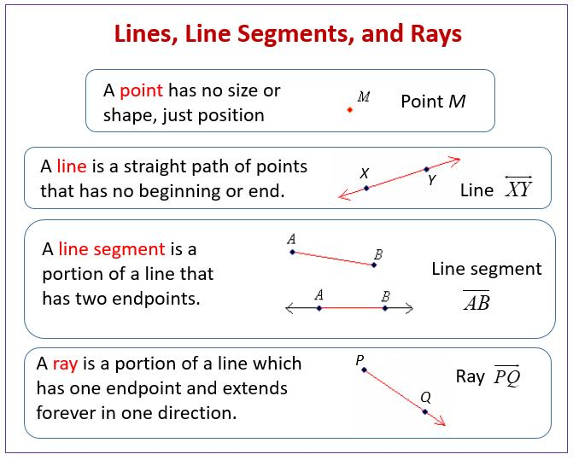
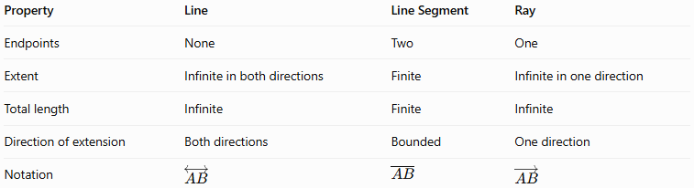
Property | Line | Line Segment | Ray
Endpoints | None | Two | One
Extent | Infinite in both directions | Finite | Infinite in one direction
Total length | Infinite | Finite | Infinite
Direction of extension | Both directions | Bounded | One direction
Notation | $$\overset{↔}{AB}$$ | $$\overline{AB}$$ | $$\overset{→}{AB}$$

Constructing Ray in Solid Geometry

Instruments Used
# Source: AI Source: Provided by: [Data Path: Persons Table -> ID Column: 1, Name_En Column: Motasem Essam] -> From: [ChatGPT] on [7/25/2026]
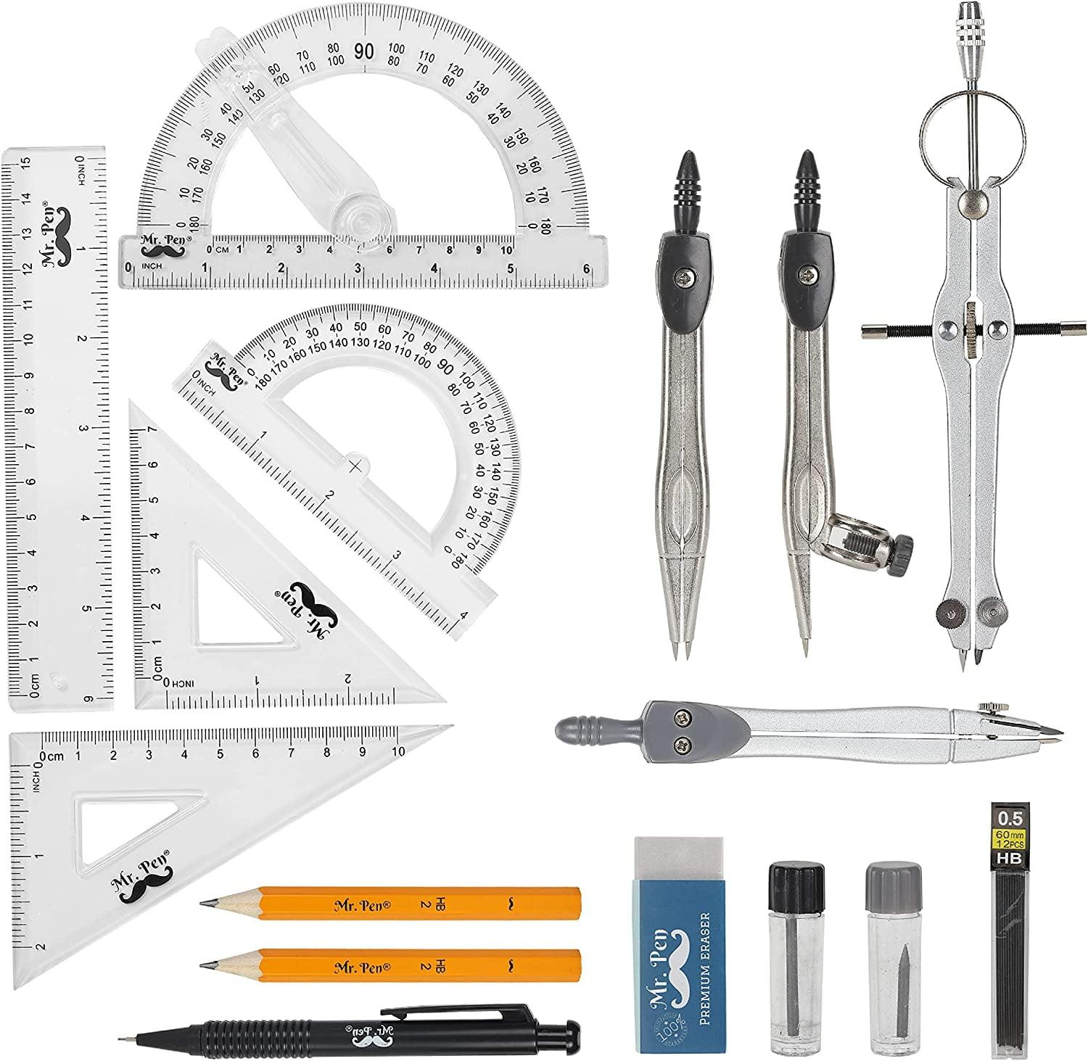
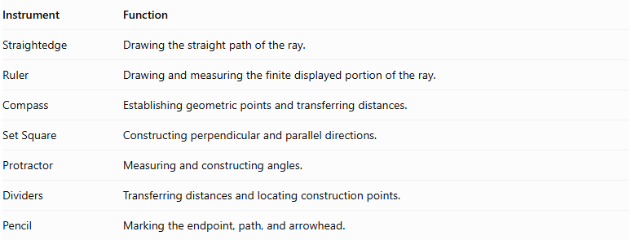
Instrument | Function
Straightedge | Drawing the straight path of the ray.
Ruler | Drawing and measuring the finite displayed portion of the ray.
Compass | Establishing geometric points and transferring distances.
Set Square | Constructing perpendicular and parallel directions.
Protractor | Measuring and constructing angles.
Dividers | Transferring distances and locating construction points.
Pencil | Marking the endpoint, path, and arrowhead.

Construction Procedures

Constructing a Ray from a Given Endpoint
# Source: AI Source: Provided by: [Data Path: Persons Table -> ID Column: 1, Name_En Column: Motasem Essam] -> From: [ChatGPT] on [7/25/2026]
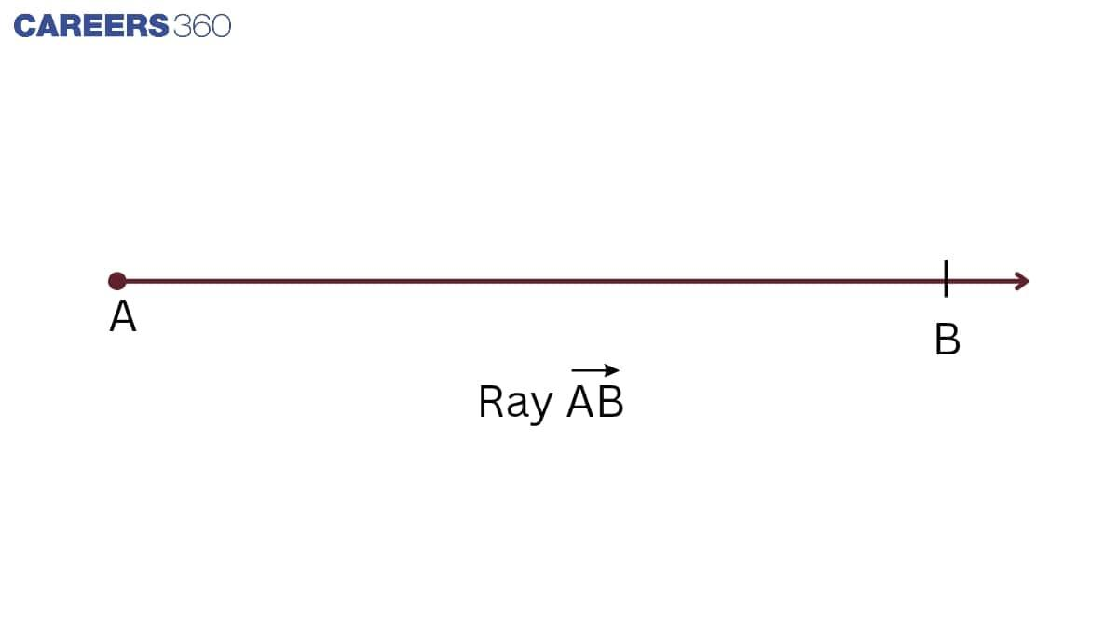
- Mark the given endpoint $A$.
- Position a straightedge so that the desired direction passes through $A$.
- Draw a straight path beginning at $A$.
- Select another point $B$ on the path.
- Add an arrow at the opposite end to indicate infinite extension.
- Label the ray $\vec{AB}$.

Constructing a Ray Through Two Given Points
# Source: AI Source: Provided by: [Data Path: Persons Table -> ID Column: 1, Name_En Column: Motasem Essam] -> From: [ChatGPT] on [7/25/2026]
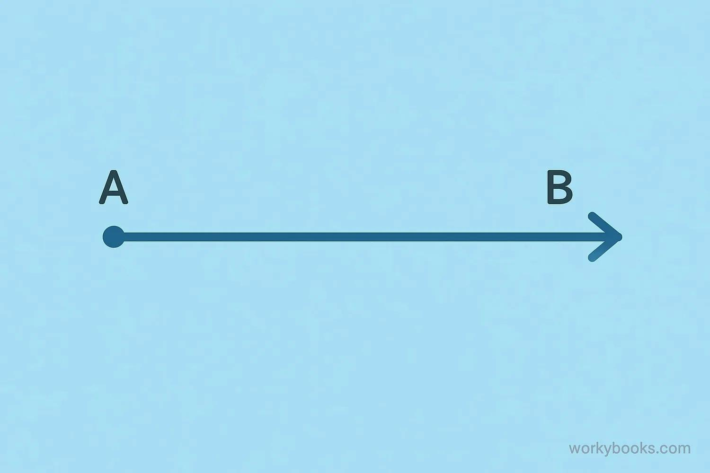
- Mark the two given points $A$ and $B$.
- Place a straightedge through both points.
- Draw the straight path from $A$, passing through $B$.
- Extend the drawn representation beyond $B$.
- Add an arrow pointing away from $A$.
- Label the ray $\vec{AB}$.

Constructing a Parallel Ray
# Source: AI Source: Provided by: [Data Path: Persons Table -> ID Column: 1, Name_En Column: Motasem Essam] -> From: [ChatGPT] on [7/25/2026]
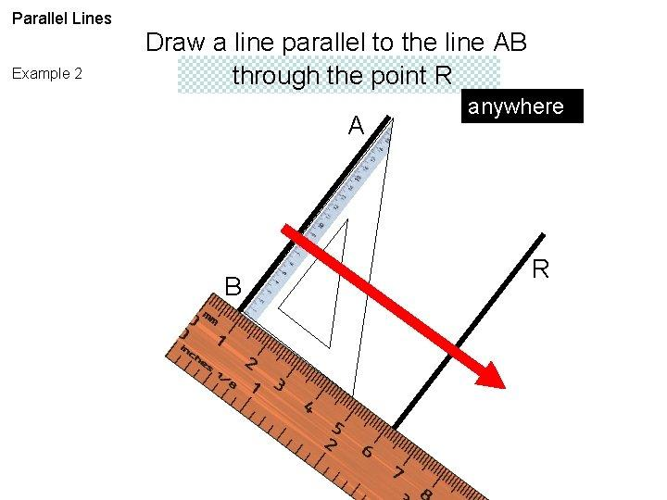
- Identify the given ray or line.
- Mark the required endpoint for the new ray.
- Use a set square and straightedge to establish a parallel direction.
- Draw the new ray from its endpoint.
- Add an arrow in its direction of extension.

Constructing a Perpendicular Ray
# Source: AI Source: Provided by: [Data Path: Persons Table -> ID Column: 1, Name_En Column: Motasem Essam] -> From: [ChatGPT] on [7/25/2026]
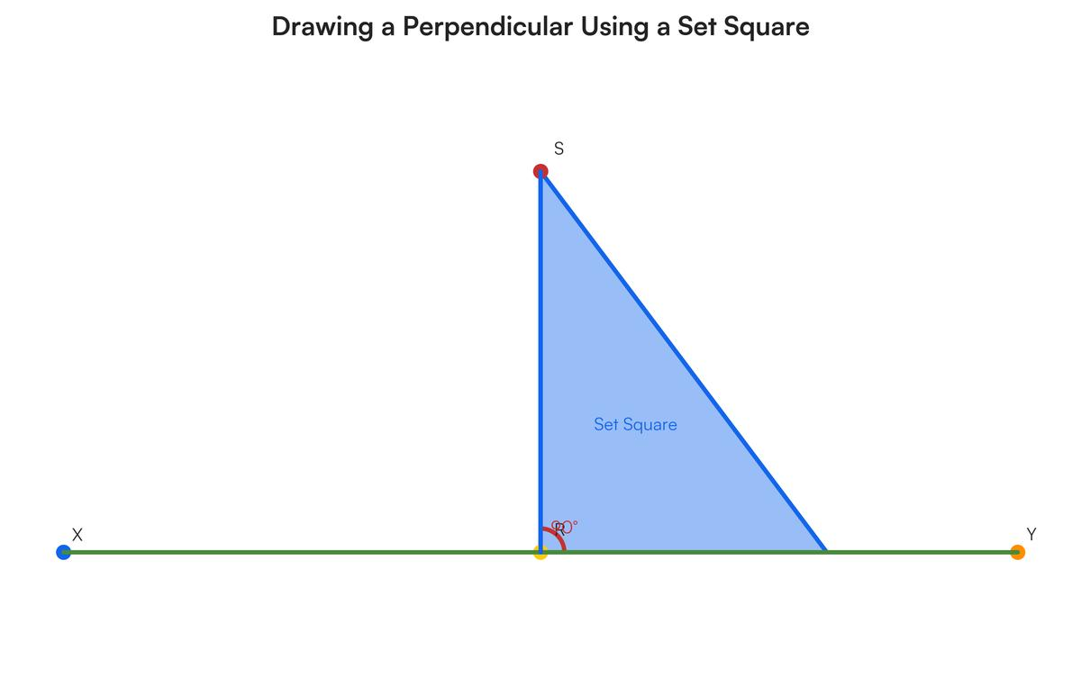
- Identify the given line, segment, or plane.
- Mark the required endpoint.
- Position a set square to establish a right angle with the reference element.
- Draw the ray from the endpoint in the perpendicular direction.
- Add an arrow to indicate its infinite extension.

Constructing an Angle-Based Ray
# Source: AI Source: Provided by: [Data Path: Persons Table -> ID Column: 1, Name_En Column: Motasem Essam] -> From: [ChatGPT] on [7/25/2026]
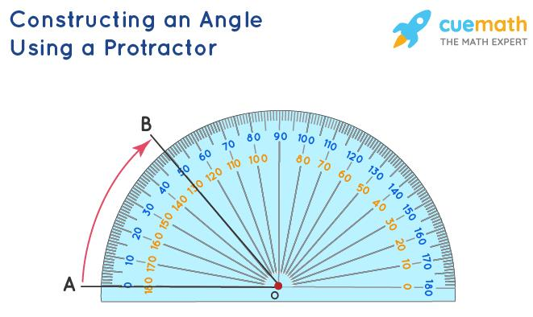
- Mark the endpoint $A$.
- Draw or identify the reference ray.
- Place the protractor's center at $A$.
- Mark the required angle.
- Draw a straight path from $A$ through the angle mark.
- Add an arrow to represent the ray's continuation.

Constructing Opposite Rays
# Source: AI Source: Provided by: [Data Path: Persons Table -> ID Column: 1, Name_En Column: Motasem Essam] -> From: [ChatGPT] on [7/25/2026]
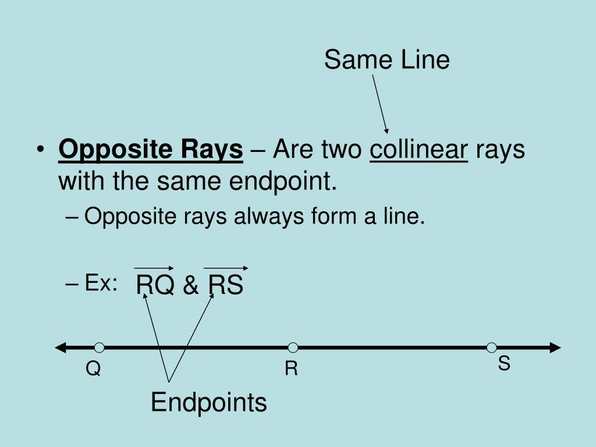
- Mark the common endpoint $A$.
- Draw a straight path through $A$.
- Place one arrow on one side of $A$.
- Place the second arrow on the opposite side.
- Label the rays $\vec{AB}$ and $\vec{AC}$, where $B$ and $C$ lie on opposite sides of $A$.
These are opposite rays because they share an endpoint and extend in opposite directions along the same straight line.

Applications of Rays in Solid Geometry
# Source: AI Source: Provided by: [Data Path: Persons Table -> ID Column: 1, Name_En Column: Motasem Essam] -> From: [ChatGPT] on [7/25/2026]
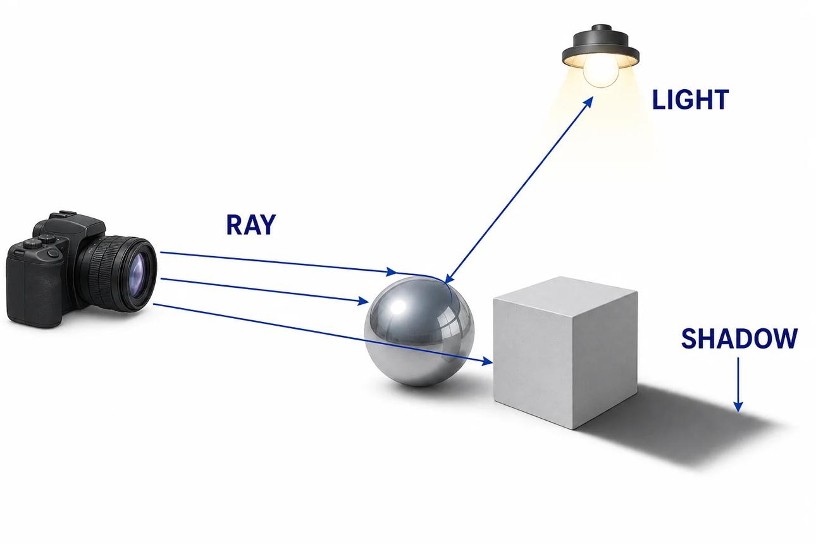
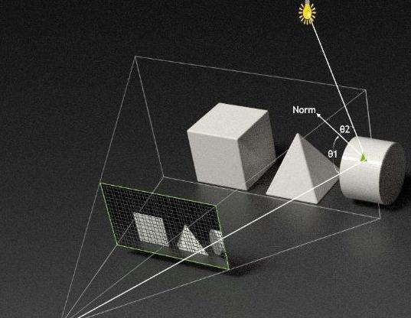
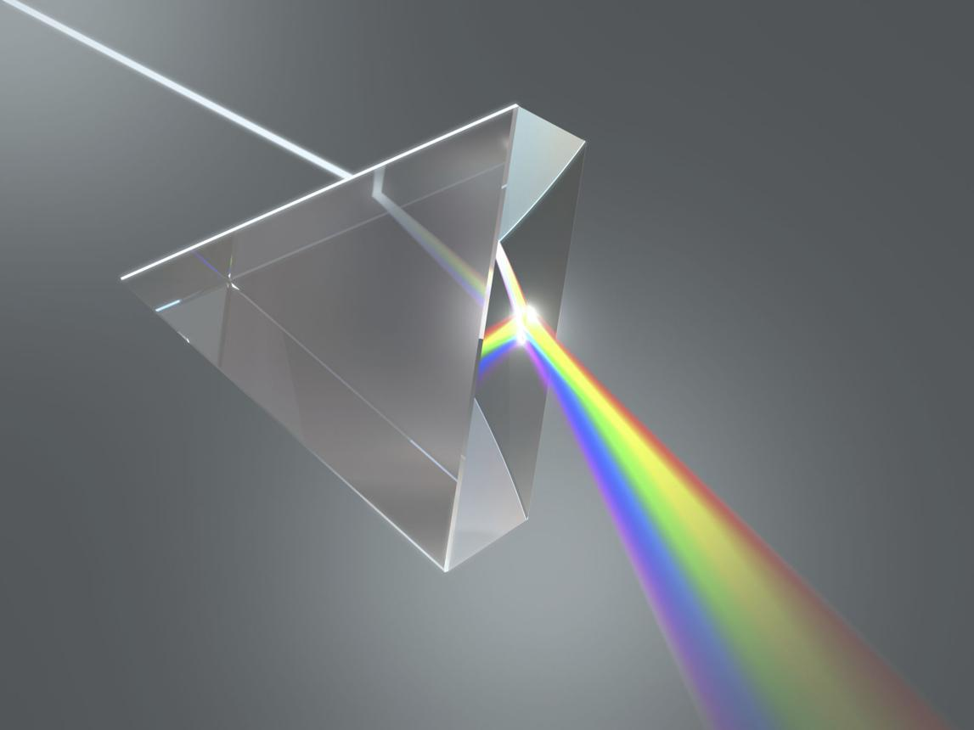
Rays are useful in:
- Optics: Representing idealized light paths and directions of propagation.
- Computer Graphics: Ray tracing and determining which objects a viewing ray intersects.
- Coordinate Geometry: Describing half-lines and directed paths in space.
- Engineering: Representing directional paths from a reference point.
- Spatial Analysis: Determining intersections between rays, planes, and solid objects.

Key Points
# Source: AI Source: Provided by: [Data Path: Persons Table -> ID Column: 1, Name_En Column: Motasem Essam] -> From: [ChatGPT] on [7/25/2026]
- A ray begins at one endpoint and extends infinitely in one direction.
- Its notation places the origin first, as in $\overset{→}{AB}$.
- A ray is one-dimensional and has no width or thickness.
- A ray in three-dimensional space can be represented using a starting point and direction vector.
- Its parametric representation uses $t≥0$.
- Rays are important in geometric constructions, optics, ray tracing, and spatial intersection problems.

Conclusion
# Source: AI Source: Provided by: [Data Path: Persons Table -> ID Column: 1, Name_En Column: Motasem Essam] -> From: [ChatGPT] on [7/25/2026]
A Ray in Solid Geometry is a fundamental geometric object representing a straight, directed path that begins at a fixed point and extends infinitely in one direction through three-dimensional space.
Rays differ from lines because they have an origin, and from line segments because they are not bounded at the other end. Their directional properties make them particularly useful for describing spatial paths and studying intersections with planes and solids.

